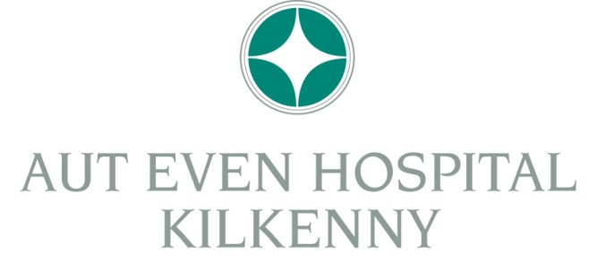
Annual Ophthalmology Meeting 2015
Ormonde Hotel, Kilkenny City Centre
20 February 2015
Conference schedule
1030 Registration
1100-1105 Opening and welcome
1105-1135 Gareth Higgins, Consultant Ophthalmic Surgeon, Aut Even
“Periocular masses and their management”
1135-1205 Sean Chen, Consultant Ophthalmic Surgeon, Barringtons Hospital, Limerick
“Prescribing in children with and without strabismus”
1205-1300 Junior presentations
1300-1400 Buffet Lunch
1400-1500 Guest Lecture: Ms Cecilia Fenerty, Manchester Royal Eye Hospital
“Emerging concepts in glaucoma management”
1500-1700 Workshops:
Optic Disc OCT- Tom Stumpf, Consultant Ophthalmic Surgeon, Aut Even
Corneal Topography- James O’ Reilly, Consultant Ophthalmic Surgeon, Aut Even
Macular OCT- David Kent, Consultant Ophthalmic Surgeon, Aut Even
1700-1730 Refreshments and Light Snacks
1730-1830 Guest Lecture: Mr David Walsh, Chief Sport Writer with the Sunday Times, London
“How Abuse of Drugs is Destroying Sport”

For further information please contact Edel Brennan on 1890 493493 or email: bookings@auteven.ie

